**TASK-05**

**EXPLANATION:**

Write a program to print following pattern.

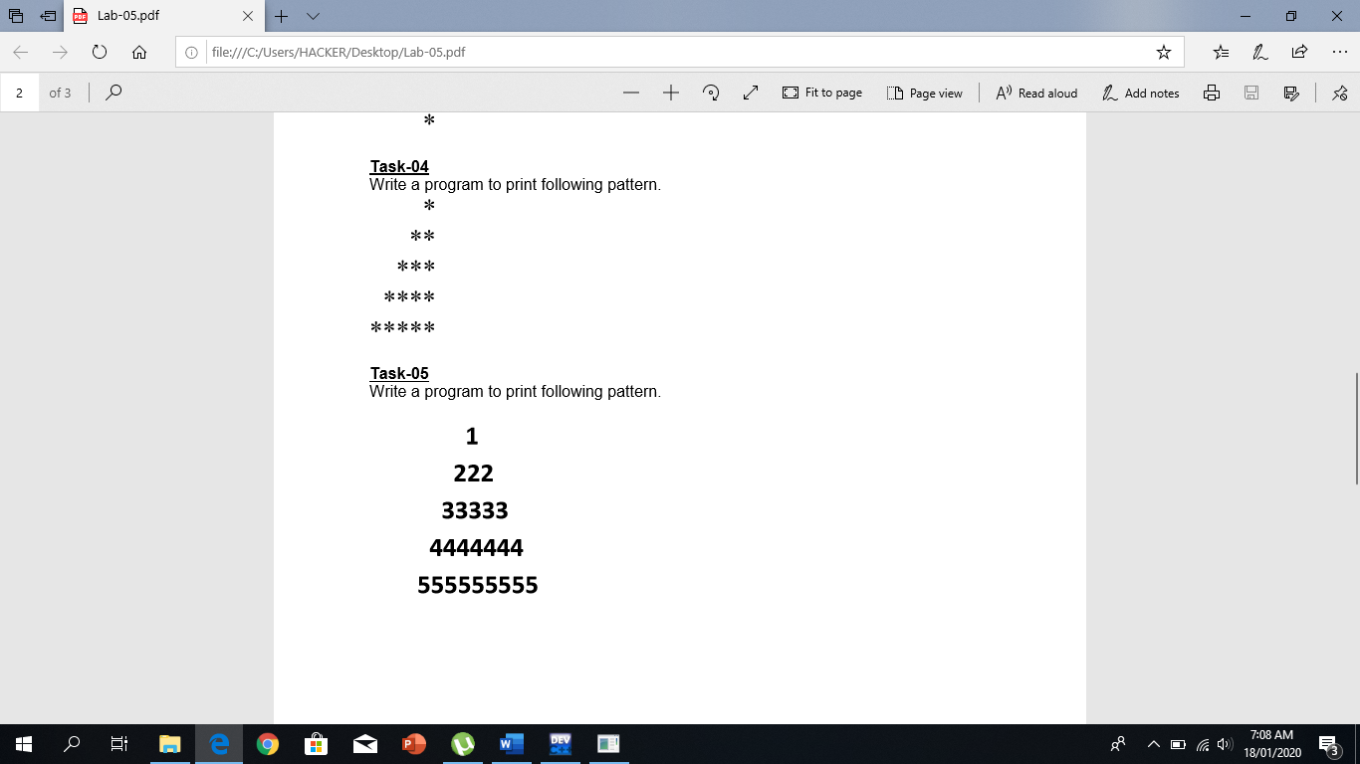

**INPUT:**

#include <iostream>

#include "abdullah"

#include <string>

using namespace std ;

int main ()

{

bool flag = true ;

while ( flag )

{

int length ;

string line = "Please enter the base or height of pyramid less than 10 : " ;

cout << line ;

while ( ! ( cin >> length ) || length < 1 || length > 10 )

{

cin_clear ( line ) ;

}

system("cls") ;

for ( int i = 1 ; i <= length ; i++ )

{

for ( int j = length - 1 ; j >= i ; j-- )

cout << " " ;

for ( int k = 1 ; k <= ( 2 * i ) - 1 ; k++ )

cout << i ;

cout << endl ;

}

flag = continuationLoop () ;

}

}

**OUTPUT:**

